# A PROJECT REPORT ON

**“ART GALLERY”**

SUBMITTED TO MIT SCHOOL OF ENGINEERING, LONI

**BY**

Atharv Patil – MITU20BTIT0015

Ayush Shah – MITU20BTIT0017

Krishnaprasd Awala– MITU21BTITD012

Pranav Padwale – MITU21BTITD006



**Under the guidance of**

**Prof. Ayesha Butalia**

**Department of** **Information Technology**

**MIT School of Engineering**

**MIT Art, Design and Technology University, Pune**

**MAEER’s Rajbaug Campus, Loni-Kalbhor,**

**Pune - 412201**

**2021-22**

Prof.Dr. Ayesha Butalia Prof.Dr. Rekha Sugandhi

Guide Head of IT Department

**ACKNOWLEDGEMENT**

I express my profound thanks to our Guide **Prof. Ayesha Butalia**

for her expert guidance, encouragement and inspiration during this Dissertation work.

I sincerely thank **Prof. Dr Ayesha Butalia**, Head, Department of Information Technology, MIT School of Engineering, MIT-ADT University, Pune, for providing the necessary facilities for completing the project.

We are grateful to **Prof. Dr Kishore Ravande**, Principal, MIT School of Engineering, MIT-ADT University, Pune, for providing us with the facilities to carry out our project work.

We also thank all the faculty members in the Department for their support and advice. We are very much grateful to our parents for their immense love, affection, help, cooperation and encouragement to complete this course.

Finally, a special thanks to all our classmates and friends who helped and

encouraged us to complete our project work.

Group member names

Atharv Patil (2205055)

Ayush Shah (2205079)

Krishnaprasad Awala (D2215004)

Pranav Padwale (D2215012)

# ABSTRACT

# First one- or two-line should be general intro about the title

Today, many artists use modern means of exploring creativity, like Illustrations, Photoshop, and computers. This type of art is called digital art.

**Second and third line about the title**

With Fresco we would like to introduce a solution to all the problems faced by the artists which is selling their work or monetizing their work.

**Approx 3 lines about introduction of topic identified and existing applications.**

Fresco is an E-Commerce Platform where users will be able to buy and sell art by listing it on the website. Other E-commerce platforms exist like Amazon, Flipkart but they do not have a favorable system for digital artists, the platforms where art is uploaded does not contain a copyright system.

**Approx 3 lines about existing technology/Methods/systems.**

# ABSTRACT

Art Gallery is an E-Commerce Platform where users will be able to buy and sell art by listing it on the website. Users will be able to upload their art on the website and completely forget about it, still, they will be able to make sales which will act as an income source for Artists. People in need of good art will be able to find appropriate art and designs for their specific needs as per their priorities. They can browse through our immense gallery of selections as per their need

**TABLE OF CONTENTS**

**Title 1**

**Acknowledgement 2**

**Abstract**  **3**

**Chapter 1. INTRODUCTION 6**

1.1 – Project Introduction **7**

1.2 – Project Profile **8**

1.3 – Project Purpose **9**

1.4 – Project Scope **9**

**Chapter 2. SYSTEM REQUIREMENT ANALYSIS 10**

2.1 – Problem Statement **10**

2.2 – Highlights **11**

2.3 – Advantages **12**

2.4 – Limitations/Disadvantages **12**

2.5 – Design/Implementation **12**

2.6 – Tools And Technologies **13**

2.7 – System Requirements **14**

2.8 – Hardware Requirements **15**

2.9 – Architecture **16**

2.10 – Use Case Diagram **18**

2.11 – Data Flow Diagram **19**

2.11.1 – Level 0 **19**

2.11.2 – Level 1 **19**

2.11.3 – Level 2 **20**

2.12 – Testing / Result **21**

2.12.1 – Website **21**

2.12.2 – Chatbot **28**

**Chapter 3. CONCLUSION 32**

3.1 – Conclusion And Future enhancements **32**

**Chapter 4. REFERENCE 32**

4.1 – Reference/Annexure **32**

# INTRODUCTION

* 1. Project Introduction
  2. Project Profile
  3. Project Purpose
  4. Project Scope

# 1.1 PROJECT INTRODUCTION

Art Gallery is an eCommerce site that specialises in selling digital art online to buyers around the world. Here you can sell vector graphics, templates, and digital assets such as illustrations, icons, fonts, textures, etc. Your works will pass a selection process before it’s approved for the platform. Here you can sell very high-quality patterns, brushes, backgrounds, and digital assets. It’s a curated site, so there’s a very tough selection and

admission process though once you get through it your art will be exposed to a very large audience.

Depending on what you need, you can choose to build a store directly on Art gallery and sell from there or integrate our service.

# 1.2 PROJECT PROFILE

|  |  |
| --- | --- |
| Project Title | Art Gallery |
| Project Category | Web Application |
| Objective | The Main Objective Of The Website Is to Create An E-commerce website for the buyers and sellers and create a whole new platform in which users can buy and sell their digital art |
| Programming Languages | HTML, CSS, JavaScript, PHP |
| Tools | Figma, Vs code, photoshop, XAMPP |
| Documentation Tool | Microsoft Office 2019 |
| Guide | **Prof. Ayesha Butalia** |
| Developed By | Atharv Patil  Ayush Shah  Krishnaprasad Awala  Pranav Padwale |

# 1.3 PROJECT PURPOSE

# Digital artists and graphic designers struggling with their art. nowadays there are a huge number of graphic designers in the world, and they face issues with selling/monetising their art.

# The purpose of this project is to make an E-commerce platform for the designers

# 1.4 PROJECT SCOPE

In Our Project, we explore how to provide services to the designers to build their shops on our website.

# SYSTEM REQUIREMENTS AND

# ANALYSIS

# 

# 2.1 Problem statement

# Problems

### **Problem 1**

Nowadays there are a huge number of graphic designers in the world who face issues with selling/monetising their art so the only option they have right now is freelancing which can be hard sometimes

### **Problem 2**

Buyers having issues finding art to use for their personal or commercial use.

# Solutions

### **Solution 1**

Providing a platform for designers where they can share their ideas and even artwork and designs

## **Solution 2**

Provides a platform for the buyers where they can easily find their needs and also get some recommended artworks as they surf the website.

# 2.2 HIGHLIGHTS

* Easy login and signup
* Various and many extensive Arts available
* Browse through the Gallery
* Easy purchasing and selling your digital art
* Easily available NFT marketplace in future

# 2.3 ADVANTAGES

* It shows visuals of the art
* User can upload their art
* They can monetize their original art if they wish to do so
* Copyright system is used for the safety of the art provided by the customer

# 2.6 TOOLS AND TECHNOLOGIES

|  |  |  |
| --- | --- | --- |
| ICON | TOOL | USAGE |
|  | Visual Studio Code | IDE |
|  | Figma | UI/UX Design |
|  | Photoshop | Logo, Icons and Other Artwork Design |
| XAMPP - Wikipedia | XAMPP | Testing the website locally |
|  | Stripe | Provides API keys for card Transactions |

# 2.7 SYSTEM REQUIREMENTS

Software requirements deal with defining software resource requirements and prerequisites that need to be installed on a computer to provide optimal functioning of an application. These requirements or prerequisites are generally not included in the software installation package and need to be installed separately before the software is installed.

Recommended System Requirements

Web browsers like

• Chrome: 69.0.3497 or above

• Microsoft Edge

And A Good Internet Connection

# 

# 2.8 HARDWARE REQUIREMENTS

•The most common set of requirements defined by any operating system or software application is the physical computer resources, also known as hardware, a hardware requirements list is often accompanied by a hardware compatibility list (HCL), especially in the case of operating systems.

• An HCL lists tested, compatible, and sometimes incompatible hardware devices for a particular operating system or application.

• There are many hardware requirements for any software or application. In the case of Art Gallery, these are the software requirements

• Recommended Donner Side Hardware requirements:

1. RAM: 500 MB
2. Processor: Octa-Core Max 1.40GHz
3. Computer with internet connection

• Recommended Server-Side Hardware requirements:

1. RAM: 8 GB.

2. Processor: Quad-Core Min. 1.40GHz.

3. Hard Disk Space: 5 GB minimum required.

# 2.10 USE CASE DIAGRAM

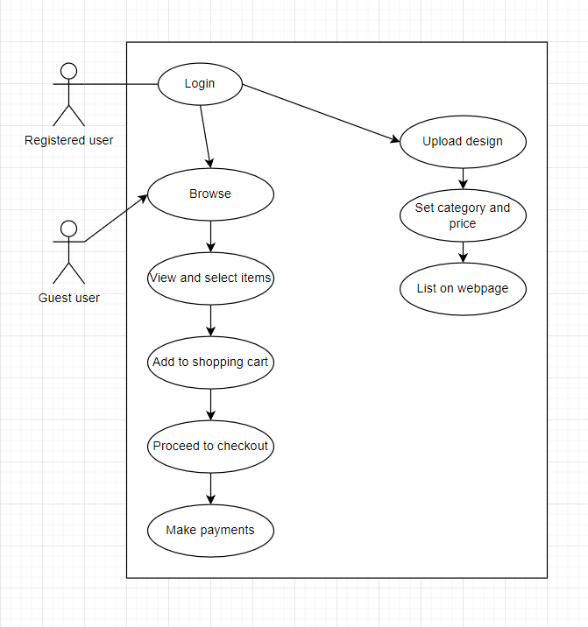

# 2.12 TESTING / RESULT

The Website is in the early phase of development and basic UI/UX is completed with the front end of the website partially complete

# 2.12.1 WEBSITE

1: This Is How the Homepage Of The Website Looks Like

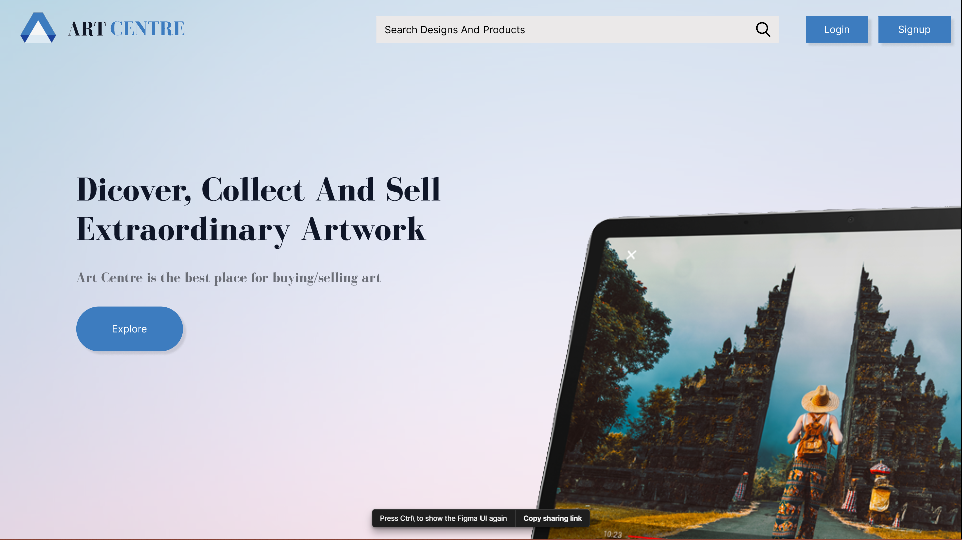

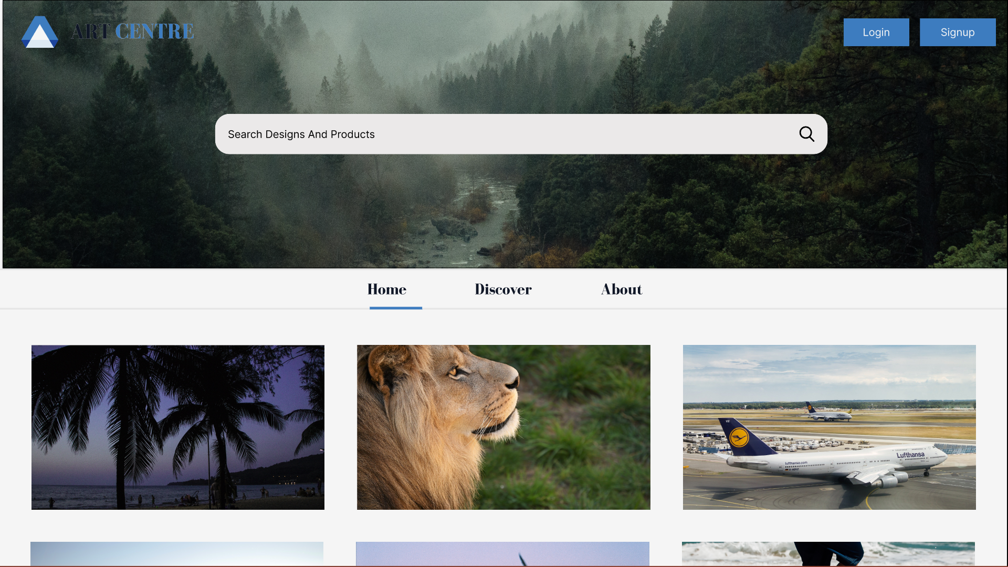

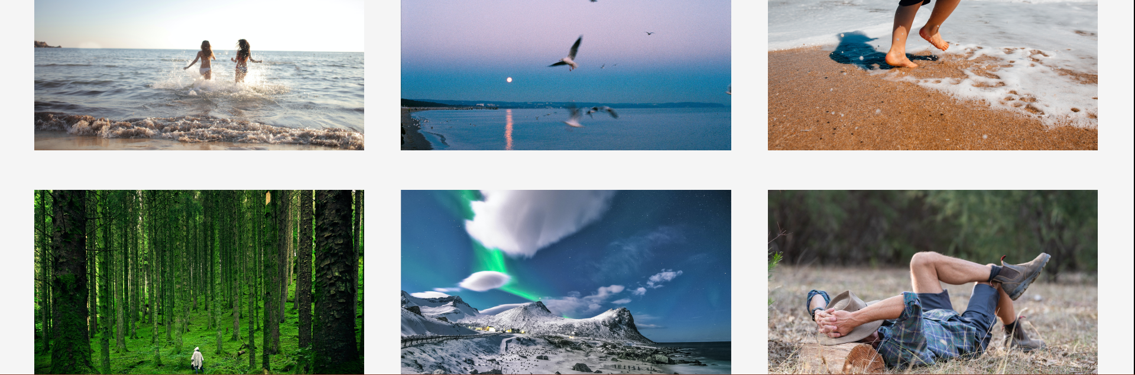

2: This is what the login page looks like:

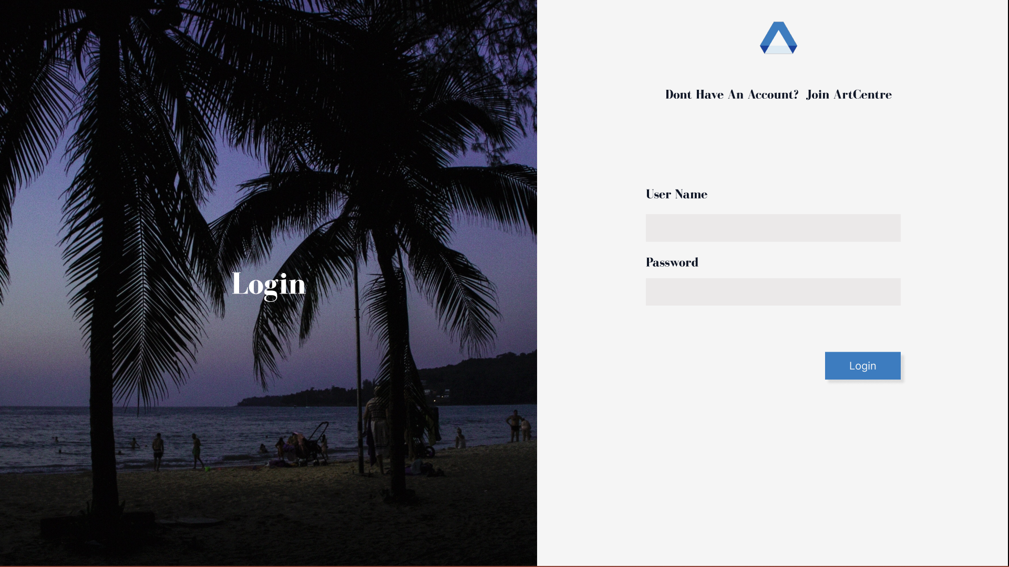

3: This is what the signup page looks like:

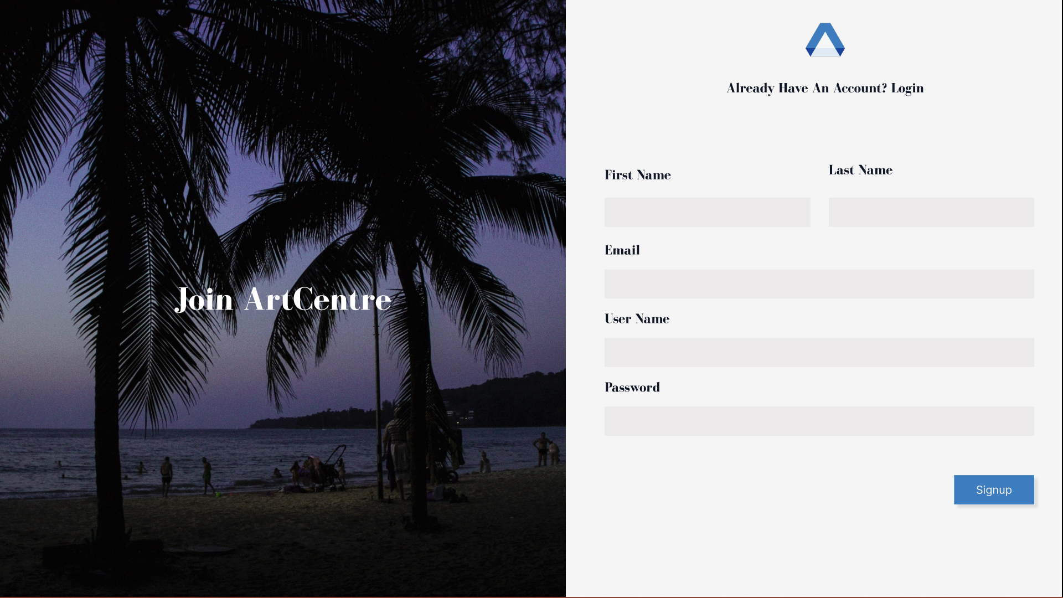

4: Discover page lets you discover the various types of art styles present on the website:

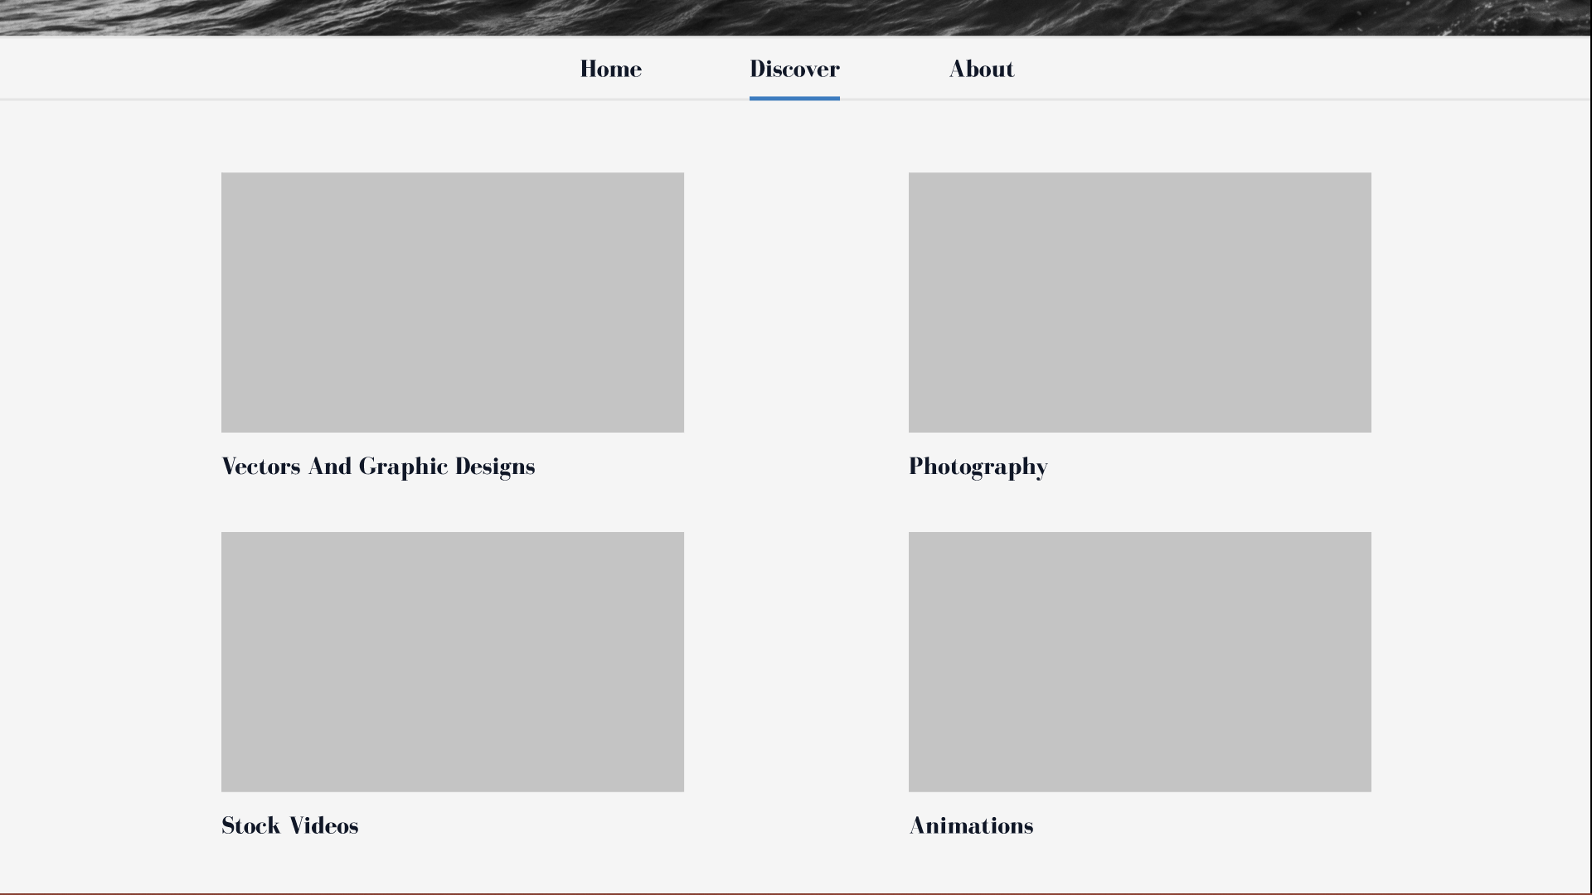

5:To add new art you can click on your profile picture and add your art there:

.

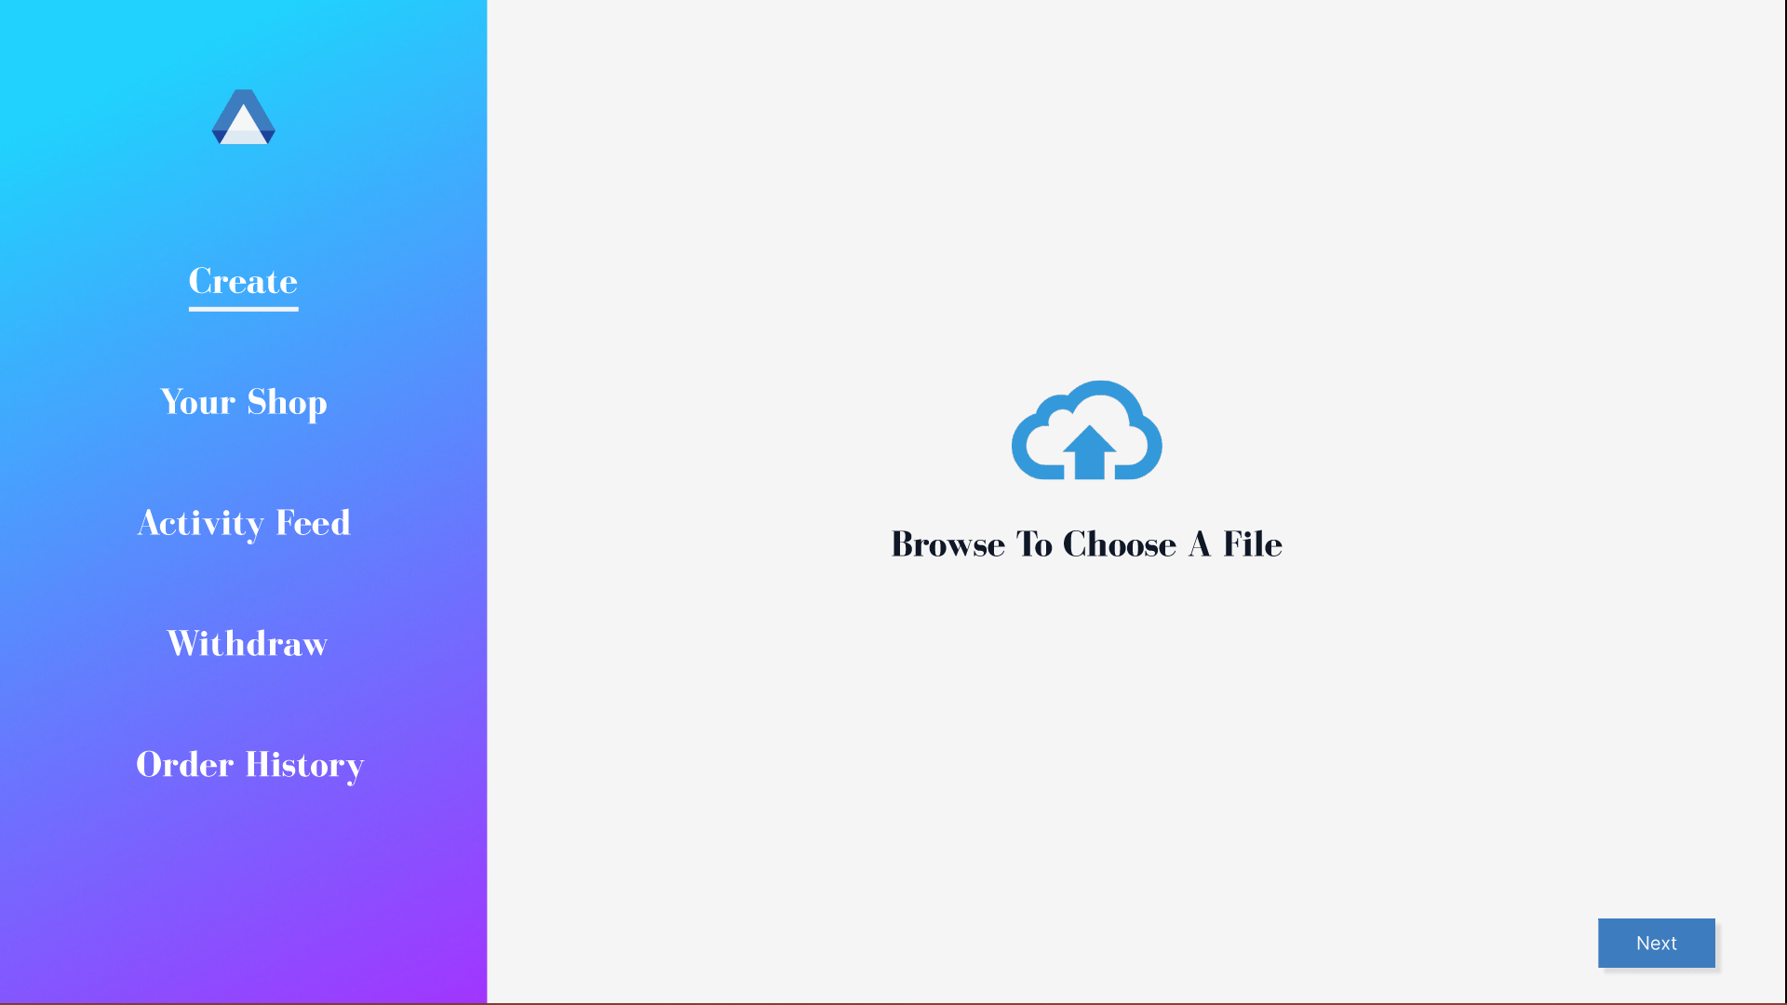

6: Click next to confirm

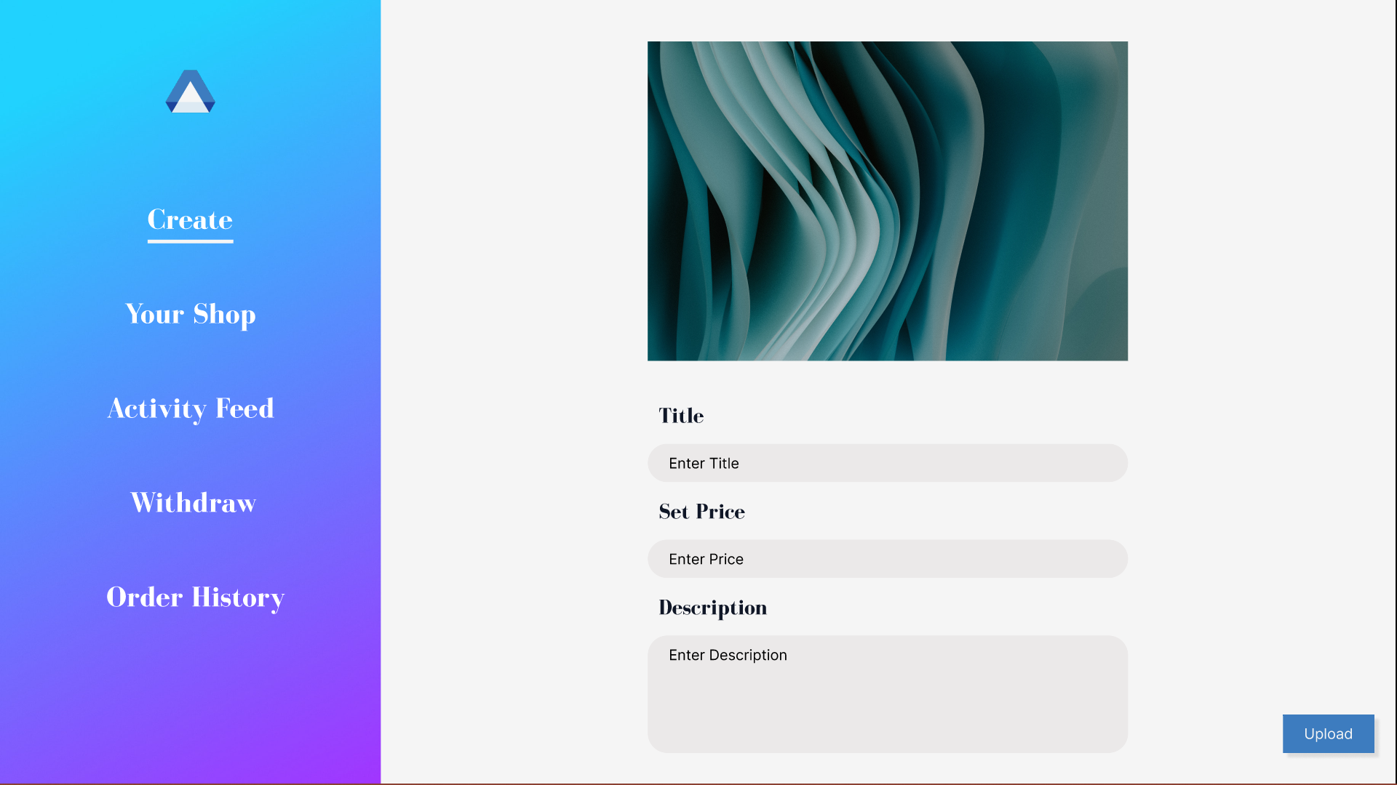

7. Your shop page:

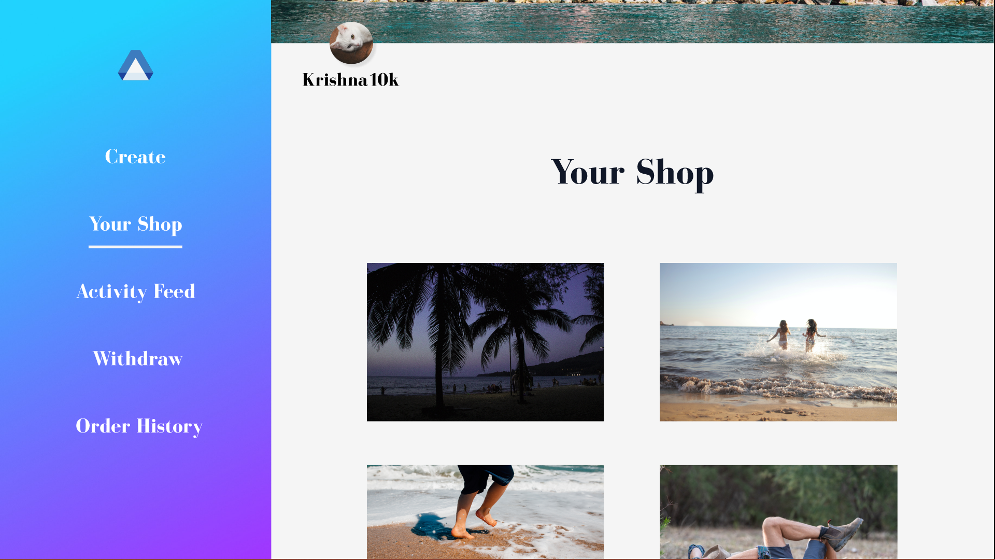

8. Activity Feed:

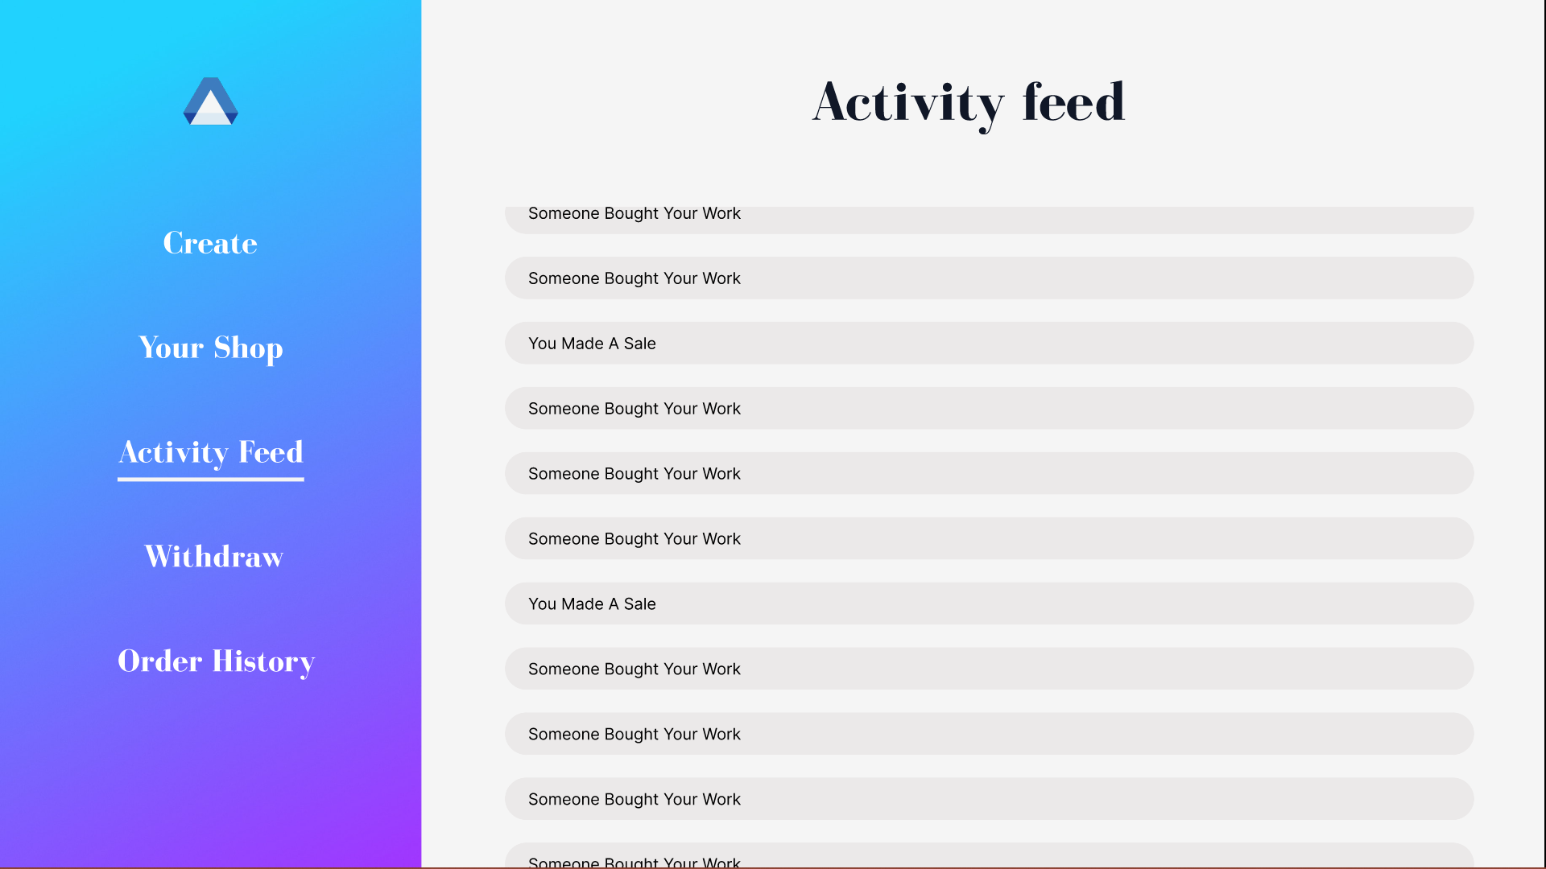

# 

# 9. Transaction history page:

# 

10. Order History:

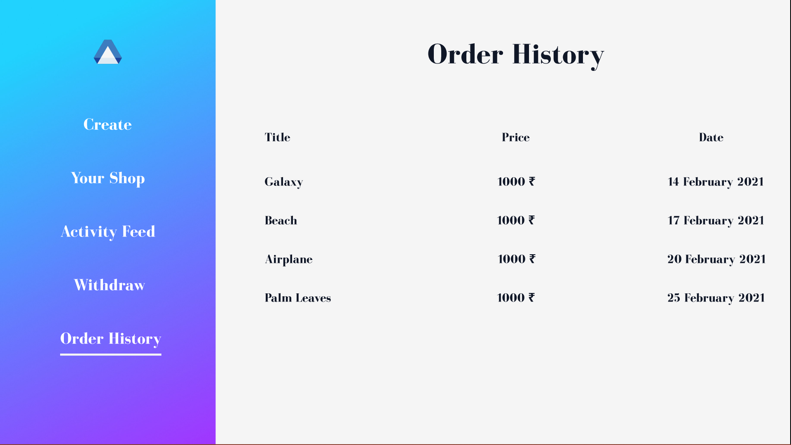

**About page:**

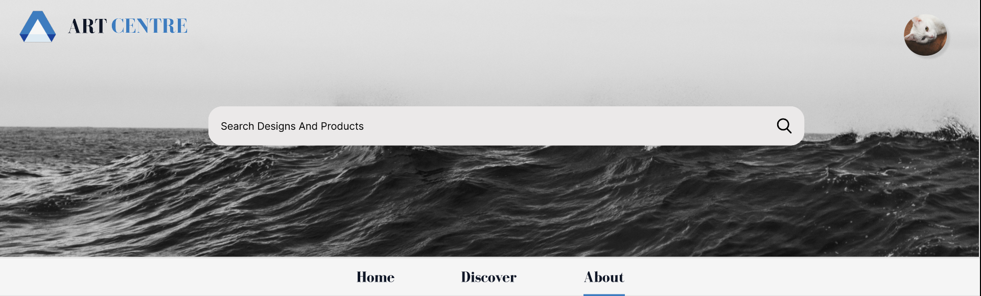

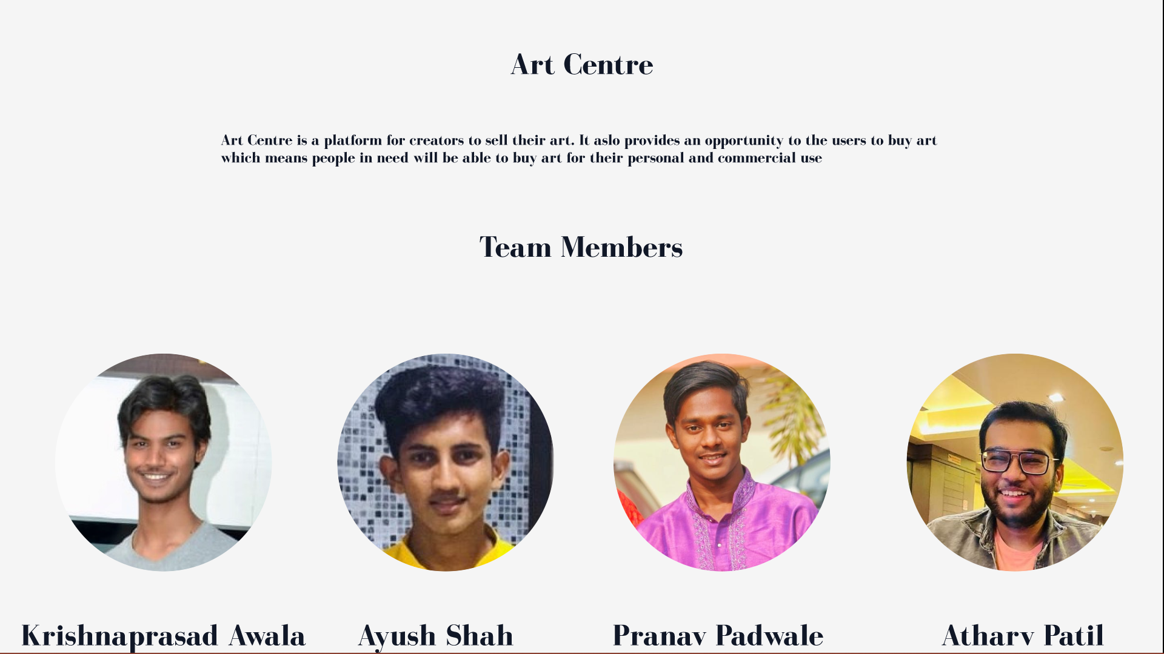

# 3. CONCLUSION

# 3.1 CONCLUSION AND FUTURE

# ENHANCEMENTS

In conclusion, artists can have their life made easy by being able to monetize their art and earn royalties for their effort. Companies can easily find small artists who can provide better art and design at a very reasonable price, saving them a reasonable amount of money in the long run

**4 REFERENCE**

# 4.1 Reference/Annexure

https://youtu.be/zcojC6PWNOQ

https://www.tutorialspoint.com/index.htm

https://youtu.be/WYufSGgaCZ8